Torticollis Information
What is Torticollis?
Normally a baby is able to move their head freely to both sides. Torticollis is a condition where the child holds their head tilted or rotated to one particular side. When a baby has Torticollis, their sternocleidomastoid muscle in their neck becomes shortened and tight causing the movement in the neck to be limited.
Sometimes when the sternocleidomastoid muscle becomes short and tight a hard lump occurs on the neck. This lump is fibrous tissue within the muscle which usually disappears over time.
Occasionally the baby’s head may become asymmetrical or flattened on one side due to them looking one way more than the other. This will usually resolve once the torticollis has been treated.
What causes Torticollis?
The condition does not always have a clear cause but Torticollis can be caused by the following:
- Difficulties during birth eg. Breech delivery
- Congenital abnormalities having an effect eg. Dislocated hips
- Positioning of the head in the womb

How is Torticollis treated?
Torticollis is usually treated through intervention from a physiotherapist. Your physiotherapist will provide stretches to complete with your baby every nappy change to lengthen the sternocleidomastoid muscle (neck muscle) and improve movement within the neck.
Your physiotherapist will also provide positioning advice for your baby. Such as placing toys and stimuli on the opposite side to which the baby prefers to look. This encourages the baby to turn their head the other way and stretch the neck muscles itself. It is also recommended that you encourage lots of tummy time so that the baby is able to improve its head control and allows it to have a short period of time without pressure on the back of its head, this is especially important if they have head asymmetry/flattening.

Torticollis Stretches
Right sided tightness and head turning preference to left
Stretch 1
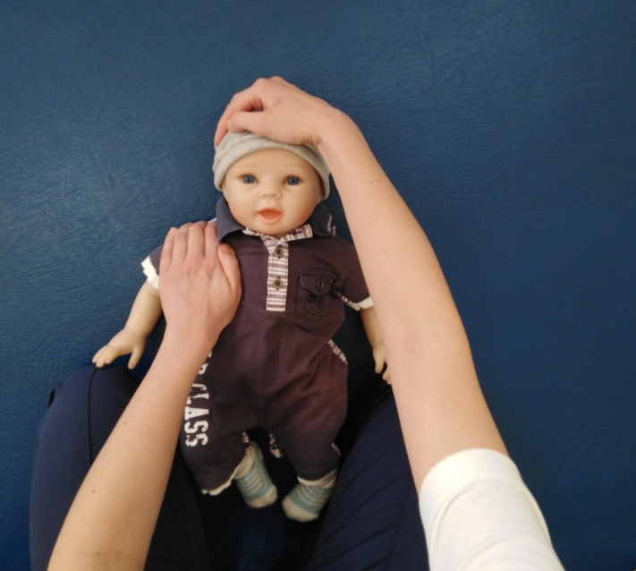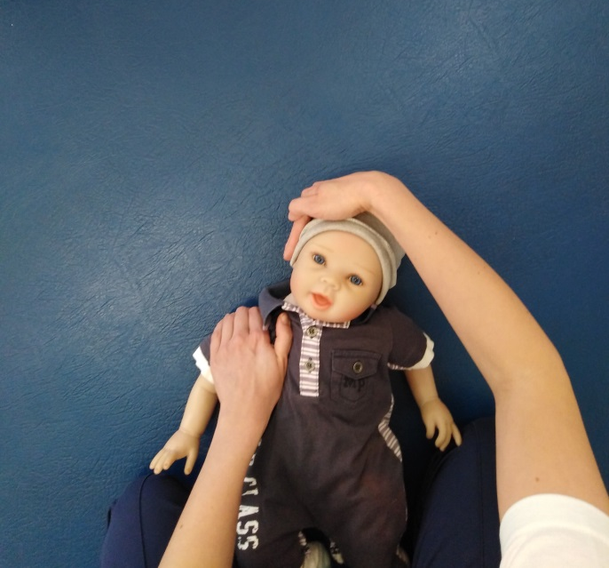
Position the baby on a flat surface in front of you;
- Bring the head into the middle before starting the stretch.
- Put your left hand on the right shoulder of the baby to secure it.
- Bring the other hand over the head and gently move the head so that the left ear is moving towards the left shoulder. Make sure to keep the head facing forwards.
At each stretch the neck should be taken as far as possible, although it is important not to fight if the child strongly resists the movement. If this occurs, wait until the child relaxes and try again.
The movement should be slow and rhythmical, as fast movements may frighten the child. Repeat the stretches three times each session. Hold each stretch for up to 15 seconds. Try to include them in your daily routine, i.e. after a nappy change or bath for example.

Torticollis Stretches
Right sided tightness and head turning preference to left
Stretch 1
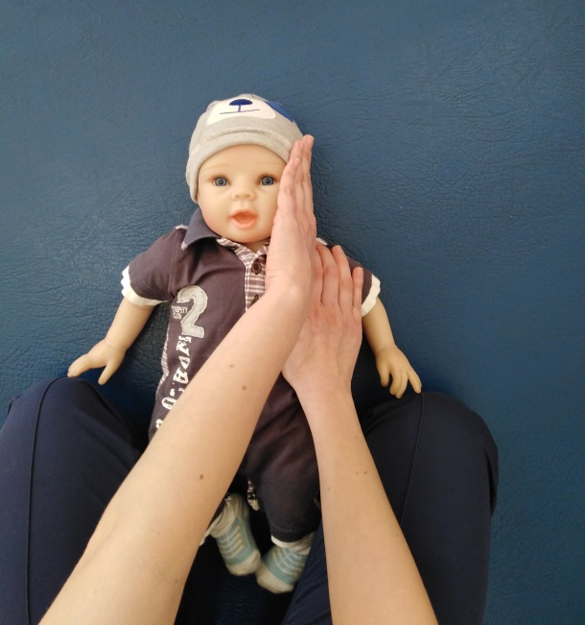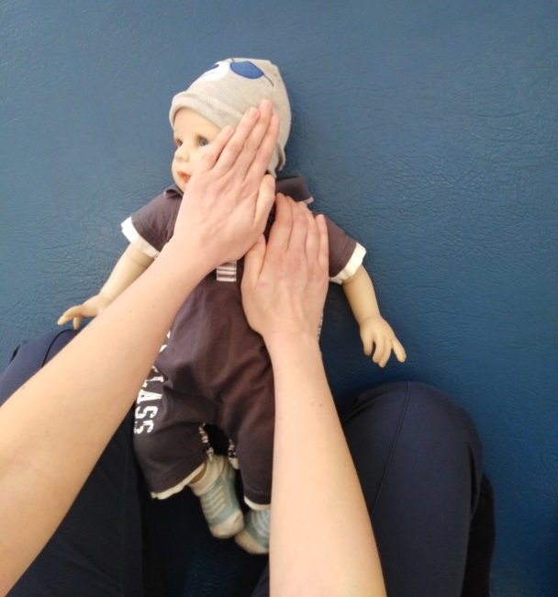
With the baby in the same position;
- Put your right hand on the baby’s left shoulder to secure it.
- Take your left hand across and place it on the left side of the baby’s face.
- Using your left hand gently bring the baby’s head over so that they are looking to the right side.

At each stretch the neck should be taken as far as possible, although it is important not to fight if the child strongly resists the movement. If this occurs, wait until the child relaxes and try again.
The movement should be slow and rhythmical, as fast movements may frighten the child. Repeat the stretches three times each session. Hold each stretch for up to 15 seconds. Try to include them in your daily routine, i.e. after a nappy change or bath for example.

